TRAFFIC MANAGEMENT SYSTEM

ER LOGICAL MODEL

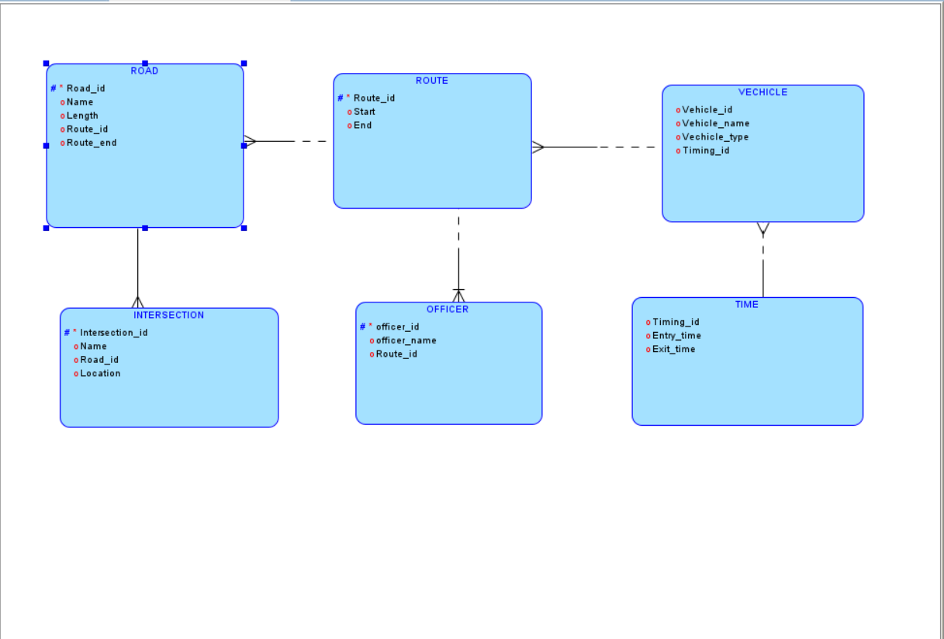

ER RELATIONAL MODEL

